ROYAL NAVAL AIR STATION YEOVILTON INTERNATIONAL AIR DAY

VISITING AIRCRAFT APPLICATION FORM
(Please note that only a limited number of parking spaces are available.
This form is does not guarantee acceptance. A confirmation e-mail of acceptance will be sent.)
1. Visitors wishing to arrive by air for the RNAS Yeovilton International Air Day 2018 are to book in their aircraft by using this proforma.
Please return to Air Operations at the address on the bottom of the form.
2. Overnight accommodation, hangarage and maintenance cannot be provided but, with advance notice, fuel can be supplied (fuel charges will be
applied at MOD rate).
3. Landing fees will be charged at standard MoD rate.
4. Admission tickets for all passengers and crew must be purchased in advance and will be checked on arrival.
(Details on purchasing tickets can be found at www.yeoviltonairday.co.uk).
AIRCRAFT & PASSENGER DETAILS
Aircraft Type
Aircraft Weight (MTOM) in Kilogrammes
Registration
Owners Full Name
Airfield where aircraft is based
Pilots Details |  | Title and Full Name
 |  | Address
 |  | Telephone
 |  | Mobile
 |  | Fax
 |  | E-mail
Passenger’s Full Names
1 |  |  |  | 4
2 |  |  |  | 5
3 |  |  |  | 6
CROWN INDEMNITY
In order to ensure visitors arriving by aircraft have adequate resources to pay claims for compensation they must hold a current Certificate of Aviation Insurance for the aircraft that must be produced prior to arrival (Which must include the CROWN INDEMNITY clause).
Please send a copy of the policy with this proforma.
ARRIVAL / DEPARTURE / FUEL
Arrivals 0800 – 1000 on Saturday
Agreed arrival times must be reasonably adhered to, failure to do so may result in the aircraft being turned away.
Departures 1800 (approx) – 2000
Departure times may be changed at late notice by the Organisers and are dependant upon SAFE airfield conditions being met post air show which is generally around about 1830.
ETA RNAS Yeovilton |  |  |  |  |  | ETD RNAS Yeovilton
Departure Airfield
Destination airfield
Fuel required |  |  | If YES state Type required
 |  |  | Quantity Required
Please sign to confirm acceptance of conditions |  |  | Signature
 |  |  | Print Surname and Initials

Address: RNAS Yeovilton,
(Attn Flight Planning Manager),
Ilchester, Yeovil, Somerset,
BA22 8HT
Telephone: 01935-45-5424
Fax 01935-45-5419
E-mail: Navyyeo-airfltplanmgr@mod.uk

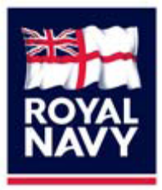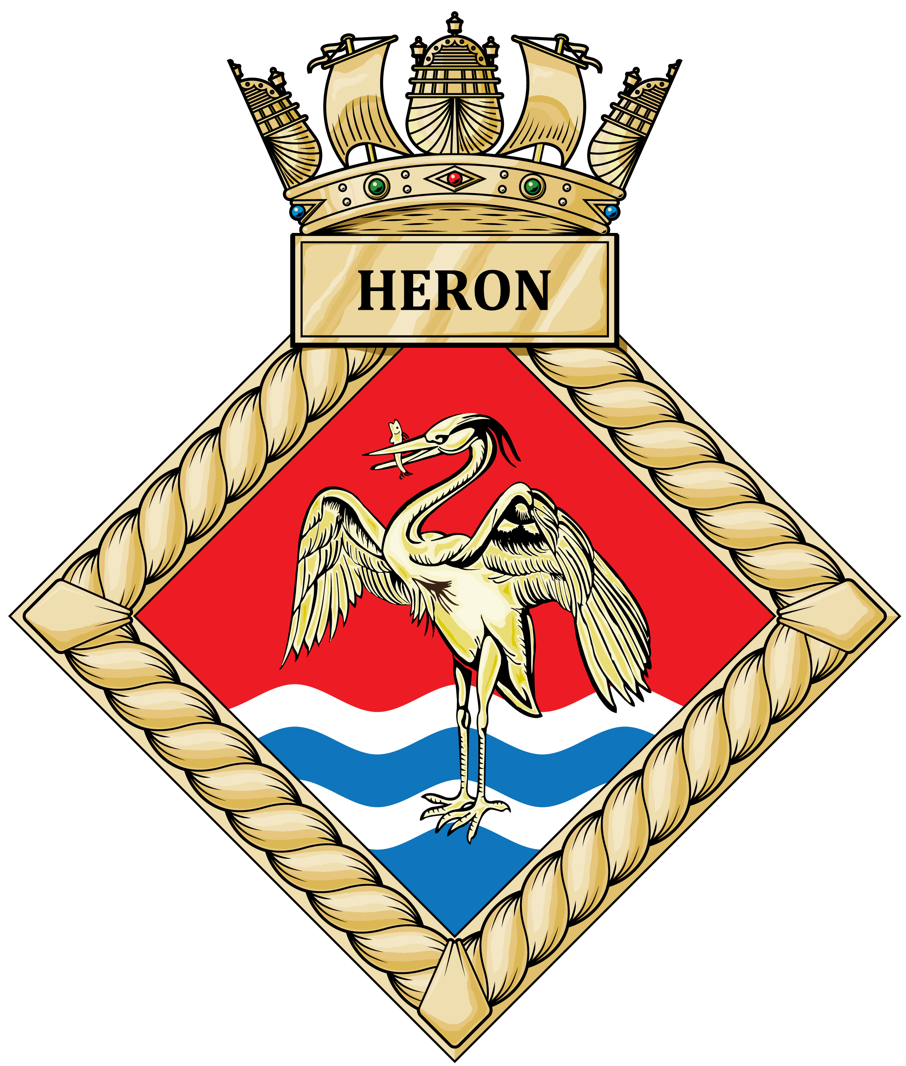

VISITING PILOTS’ GUIDE TO RNAS YEOVILTON

RNAS Yeovilton is a complex and busy airfield that simultaneously operates a multitude of fixed and rotary wing aircraft. There are several landing surfaces that may be used at any one time, so visiting aircraft are likely to encounter significant activity taking place either side of the runway in use. Therefore, it is imperative that all arrival and departure procedures are closely followed and all ATC instructions are complied with in full.

When operating in and out of RNAS Yeovilton, you may be asked to comply with certain instructions that you are unfamiliar with. The aim of this guide is to highlight Yeovilton recovery and departure procedures and explain what to expect when dealing with Air Traffic Control.

ARRIVALS

The initial contact frequency (ICF) is 123.3. If Yeovilton cannot be raised on the ICF, then a call to Yeovilton LARS on 127.350 is the best option.

You will be asked 2 questions:
- What type of service do you require?

BASIC SERVICE - The Radar Controller will be providing a “listening watch” only but will provide pertinent weather and aviation information. You are responsible for your own collision / terrain avoidance.

TRAFFIC SERVICE - The Radar Controller will keep a closer watch on your track and ADVISE you if any traffic comes with 5nm / 3000ft of your aircraft. This is the best type of service for TCAS fitted aircraft as basically we tell you about contacts and you avoid if required.

DECONFLICTION SERVICE - The Radar Controller will provide avoiding action on all tracks within 5nm / 3000ft of you aircraft and maintain separation. This will result in you being driven around the sky and potentially delay your arrival unless you call “visual” or are content to continue. This service can be very hard work for the controller when there are good VMC conditions. (In poor weather there are not as many tracks to avoid and is easier to deconflict).

You should choose the appropriate service for your Instrument rating and flight conditions.

- Are you familiar with Yeovilton as published?

Are you familiar with the layout of the airfield (runway configuration etc.) as laid out in Pooleys. If the answer is NO then the Controller will brief you on the runway length, circuit direction, overshoot procedure and anything else relevant.

IFR APPROACHES

For IFR flights or when the weather is poor, an ILS is available when RW27 is in use.

No other runways are fitted with ILS, which means either a PAR or an SRA approach will be available.

All instrument approaches to Yeovilton are flown on the Yeovilton QFE.

ATC will expect pilots to accept a Radar Service in order for vectors to be provided to the final approach. Whilst positioning for the final approach, ATC will instruct pilots to conduct cockpit checks and report when those checks are completed. It is understood that pre-landing checks vary between ac types, so a simple acknowledgement that “cockpit checks are complete” is all that is required from the pilot.

IFR approaches are all done on a single frequency, so when on final approach the Talkdown controller will establish contact and conduct a QFE check with a readback for safety.

ILS approaches will also be monitored by the Talkdown controller who will conduct the same QFE safety check.

Final clearances to use the runway will be issued either at 3nm or 2nm finals. If the clearance is delayed to 2nm, you will be informed by the controller and told “final clearance delayed, continue the approach.”

If a clearance cannot be issued, you will be instructed to “break off the approach.” At this point you will be asked if you are visual with the airfield. If you are visual, you will be told to join deadside. If not visual, you will be instructed to “execute the missed approach procedure.”

VFR APPROACHES

The preferred method is to conduct a straight-in join for the duty runway. Once you are visual with the airfield, you will be transferred to Yeovil Tower on 120.800 Mhz. A left or right base join for the duty runway may also be possible, but will depend on visual circuit activity.

All procedures within the visual circuit require a positive clearance from the Tower controller. All aircraft must ensure they have a clearance to land before using the runway. If a clearance has not been issued, a ‘go around’ must be initiated no lower than 100ft.

DEPARTURES

When departing from Yeovilton, pass your flight details to the Ground controller on 122.1 before requesting a clearance to taxy. Again, you must receive a positive clearance to taxy before using any of the airfield surfaces.

Once at the hold, you will be transferred to Yeovil Tower on 120.800 MHz for your departure clearance.

When you have received a departure clearance, you are to climb straight ahead and remain clear of helicopter VFR routes, Yeovil Westlands and RNAS Merryfield. Once clear of the visual circuit, you will be instructed to continue with Yeovil Approach on 123.300 MHz.

QUESTIONS

If you have any questions about Yeovilton procedures, or you wish to speak to someone regarding a booking, then please contact us on 01935 455243 (ATC Supervisor) or 01935 455497 (Air Operations).

