QHM RISK ASSESSMENT TEMPLATE AND GUIDANCE NOTES FOR EVENTS ON THE DOCKYARD PORT OF PORTSMOUTH
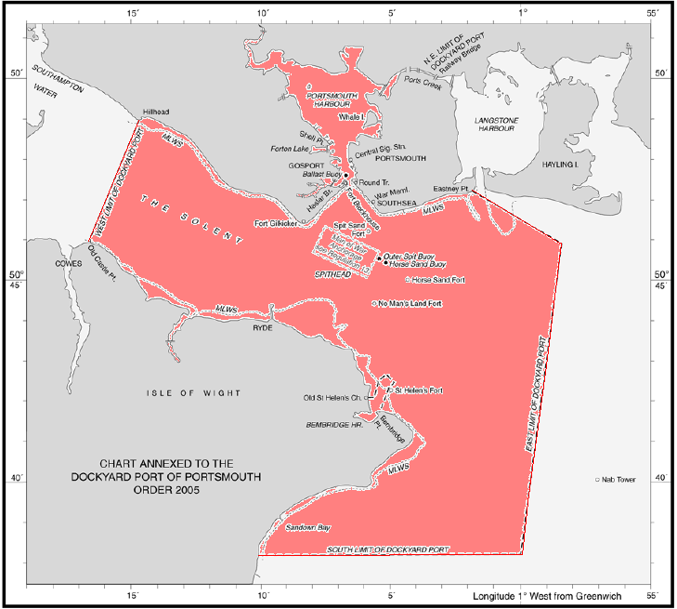
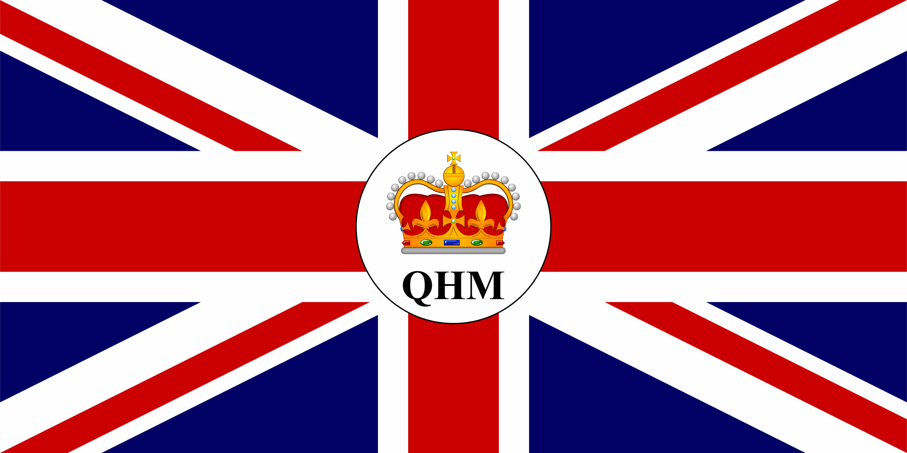

INTRODUCTION
If an event is to be held within the limits of the Dockyard Port of Portsmouth (DPP) a Risk Assessment is to be submitted and approved by the Queens Harbour Master (QHM) prior to the event being held. If the event has the potential to cross into bordering jurisdictional harbour authority areas it is the responsibility of the organiser/ club / group to contact and complete documentation associated with those harbour authorities.

QHM definition of “event": any vessel/s, craft or person/s participating in an organised gathering and/ or scheduled activity that may affect the safety of navigation or impact directly or indirectly on any other waterway users on the Dockyard Port of Portsmouth.

SUBMISSION
All QHM documentation e.g. risk assessments, event plans etc for the proposed event should be submitted to QHM direct via the email: portsmouth@qhm.mod.uk
# THIS DOCUMENTATION IS REQUIRED 28 DAYS PRIOR TO THE EVENT DATE #
(Dockyard port of Portsmouth in pink) NOTE: ANNUAL RISK ASSESSMENTS EXPIRE ON 31 DEC AND MUST BE REVIEWED

EVENT ORGANISERS AND/ OR DESIGNATED PERSONS SHOULD TAKE NOTE OF THESE 3 KEY POINTS

1. The primary responsibility for the safety of participants lies with the participants themselves. Beyond that, the organiser/ club/ group are likely to have a duty of care and must ensure that the event is managed as safely as reasonably possible. A submitted risk assessment approved by QHM does not eliminate the responsibility of the organiser/ club/ group to ensure the safety of all their participants.

2. QHM has General Directions and/or “Byelaws” in force and these may impact on the setting of courses and other aspects of an event. Organisers/ clubs/ groups and their participants all need to be aware of these. It is imperative that organisers/ clubs/ groups clearly indicate the location/s that the event/s will be held. Organisers/ clubs/ groups should take all reasonable steps to promulgate General Directions/ restrictions to their participants

3. Event conflicts are inevitable in time, date or place. Where possible these conflicts should be addressed between each respective organiser/ club/ group in advance, rather than burdening QHM. All events will be prioritised on a “first in” basis.

NOTIFICATION AND EVENT RISK ASSESSMENT GUIDANCE NOTE

The Dockyard Port Marine Safety Policy requires QHM Portsmouth to ensure that risk assessments are carried out to identify and minimise risks which may result in personal injury, damage to property and impact the environment.

Although many organisers/ clubs/ groups are now familiar with the undertaking of appropriate risk assessments for each of their respective activities, for some a formal risk assessment is still a novel concept. The purpose of this QHM guidance note and template is to facilitate the process for those less familiar with undertaking risk assessments.

QHM has defined 5 main categories for events being held in the DPP: MAJOR, MEDIUM, SMALL, SWIM and ANNUAL.

MAJOR – This is an event that will have a significant and potentially disruptive impact on the operation of the DPP. This event will require special arrangements agreed in advance with the QHM. The Risk Assessment will need to be prepared in consultation, where appropriate, with the emergency services and stakeholders. An example of such an event is the Americas Cup World Series.
QHMs criteria for a MAJOR event includes but not limited to;
- Multiple participating vessels/ craft,
- An expected spectator fleet in excess of 1,000,
- An event where an exclusion zone is requested by organiser or imposed by QHM.
# PLEASE NOTE MAJOR event organisers will need to submit an “Event Plan” as well as the Risk Assessment.
The Event Plan includes, but is not limited to:
- An itinerary of each day’s scheduled activities on and over the water.
- Where and when participating vessels will arrive and leave race location.
- An on-water management plan for marshalling.
- A complete communications construct and how each relevant authority is included.
- An Emergency management plan.

MEDIUM – This is an event that will have a noticeable impact on the operation of the DPP for which QHM would need to consider special arrangements in advance e.g. putting in place exclusion zones. Event examples of this category are Portsmouth Triathlon, P1 British Powerboat Championships, Oil Spill Exercise and Sailing regattas.

SMALL – This is an event having little or no impact on the overall operation of the DPP and has minimal risks to participants and non-participants. For this category of event a formal risk assessment is still appropriate. A SMALL event may not require the in-depth review that a MAJOR or MEDIUM requires. The QHM Risk Assessment Template is to be used to notify QHM. An example of a SMALL event is Scout Kayak group conducting a training exercise.

SWIM – This is an event that has swimming as either the primary activity or is part of a bigger event e.g. Cross Solent Swim or triathlon.

ANNUAL – This type of event is one where a club holds multiple events over the calendar year period. The events are held in the same location/area with no external influences that could potentially alter the original identified risks that have been assessed in the Risk Assessment. This category is best used by Sailing and Yacht Clubs who have a pre-planned annual calendar. EACH event on the clubs planner needs to be placed in the Risk Assessment. Any event not part of the annual event calendar will need a separate Risk Assessment completed and submitted.

How to complete the following Risk Assessment

Pages 4 – 17 must be completed by the organiser/ club/ group Designated Person or delegate who is responsible for the events safety.

It may seem that there are repetitive questions throughout, but ensure all sections are completed where relevant. Even if you feel it has been previously stated within the document, please complete all relevant sections.

Below numbered guidance notes correspond with relevant sections within Risk Assessment Template.

1. Introduction: Please supply an overview of the event, date or dates of event. The number of participants expected the type and size of vessel/ craft participating in event. Who is responsible for the organisation of event. Is the event new or has it been held previously

2. Start of Event: Please stipulate the precise location for the start of the event. Include the times of the start.

3. Event Area: Description of the event/racing area showing the boundaries. Please stipulate, as the organiser, if you feel there will be any likely impact on port operations. Please insert a chart graphic or draw a graphic on page 8 indicating location of event and any desired buoy positions.

4. Finish of Event: Please stipulate the finishing location. Where appropriate please stipulate the timeframes for the event’s completion.

5. Manning and Race Control: Please include the plans for the effective event management of the event. This includes the organisational structure, event/race control location and any emergency plans.

6. Risk Assessment: Please stipulate that a quantitative assessment of the event risks both before and after the control measures has been done. A final risk assessment is based on a judgement of the likely effect that the control measures will have in reducing the event risks. The QHM risk assessment template is supplied for ease of completion and submission.

SUBMISSION
Please submit all documentation to QHM via the email: portsmouth@qhm.mod.uk
# THIS DOCUMENTATION IS REQUIRED 28 DAYS PRIOR TO THE EVENT DATE #
NOTE: ANNUAL RISK ASSESSMENTS EXPIRE ON 31 DEC AND MUST BE REVIEWED

QHM Risk Assessment Template

________________________Event Category
(Small, Medium, Major, Swim, Annual) Distribution list: (who will receive a copy)
□ QHM Portsmouth
□ ABP Southampton
□ Coast Guard
□ Police
□ Ambulance
□ Fire & Rescue
□ Portsmouth Council
□ Local Ferry Companies

CLUB/ GROUP/ ORGANISER:
(E.g. Perfect Portsmouth Yacht Club)

EVENT TITLE:
(E.g. Better Ever Yacht Race Regatta)

DATE/S:

Event Title: _____________________ QHM Safety Risk Assessment
(E.g. Better Ever Yacht Race Regatta)

1. Introduction:

----------------------------------------------------------------------------------------------------------------------------------------------------------

2. Start of Event:

----------------------------------------------------------------------------------------------------------------------------------------------------------

3. Event Area:

----------------------------------------------------------------------------------------------------------------------------------------------------------

4. Finish of Event:

----------------------------------------------------------------------------------------------------------------------------------------------------------
5. Manning and Race Control:

----------------------------------------------------------------------------------------------------------------------------------------------------------

6. Risk Assessment:

-----------------------------------------------------------------------------------------------------------------------------------------------------------------

Notes:

---------------------------------------------------------------------------------------------------------------------------------------------------------------------

Event Title: QHM Risk Assessment _ _____ Event Category
(E.g. Better Ever Yacht Race Regatta) (Small, Medium, Major, Swim, Annual)

Event Title: | Date(s) of Event: |  | Is a Local Notice to Mariners (LNTM) Requested?  □YES □NO  Is a draft LNTM included in submitted documentation?  □YES □NO
Event Operating Area: | Event Timeframe/Operating Period:
Number of participating vessels/craft/ persons: | Vessel type/s or design:
Organising Company/ Club/ Group:  Telephone No: | Event Website:
Event Officer | Email:
Event Officers Mobile Phone No: | Authorities Informed: | If any additional documents submitted with this Risk Assessment please list. | Date Submitted:
VHF Channel/s to be used and monitored during event: | QHM |  | ___ /___ /______
Event Committee VHF Call sign: |  |  | ___ /___ /______
QHM Risk Assessment Prepared by: |  |  | ___ / ___ /______
QHM Risk Assessment prepared date: |  |  | ___ /___ /______
Additional Comment/ Other:

Plan of Event/ Racing Area (Draw or insert graphic) Event/Course(s) Configuration (Draw or insert graphic)

Event Title: QHM Risk Assessment _______ Event Category
(E.g. Better Ever Yacht Race Regatta) (Small, Medium, Major, Swim, Annual)

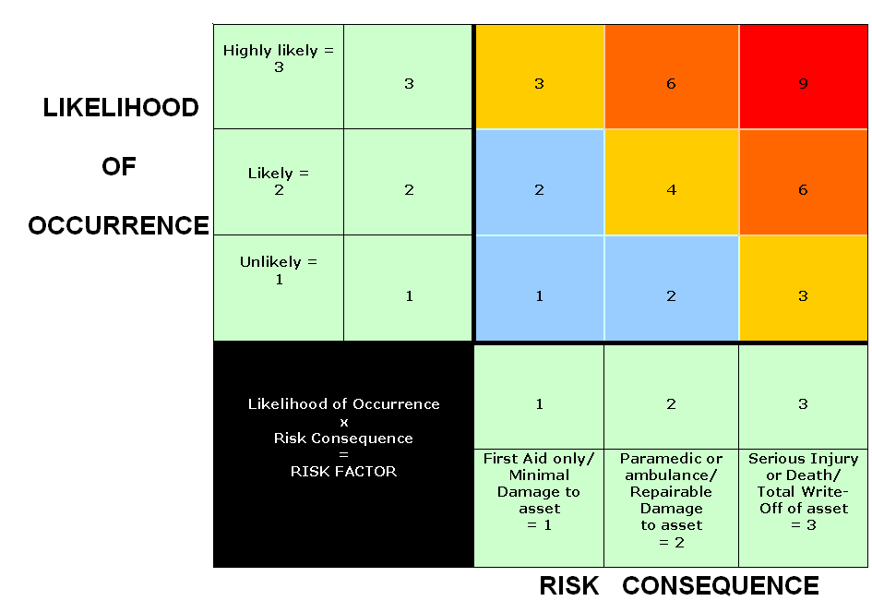

1  = | 2  = | 3  = | 4  = | 6  = | 9  =
Minimal Risk | Minimal Risk | Moderate Risk  (further control measures required to keep risk as low as reasonably possible) | Moderate Risk  (further control measures required to keep risk as low as reasonably possible) | High Risk  (further control measures required before QHM approval) | Unacceptable Risk

 | No | Description of Hazard | Likelihood of risk occurring  A | Risk Consequence  B | Risk  Factor  A x B  = | Primary control Measures* (choose from the “standard list” overleaf or add your specific control measures to list) | New Likelihood of risk occurring  C | New Risk Consequence  D | Final Risk Factor Assessment  Unacceptable risk=9  High risk=6  Moderate risk= 3-4  Minimal risk = 1-2  C x D  =
EXAMPLE | N/A | Race craft collide with another race craft | 3 | 2 | 6 | 1.2, 1.4, 1.7,  2.2, 2.3, 2.5,  2.9 | 2 | 2 | 4
1.  Vessel interaction | 1.1 | Racing boat with another racing boat
 | 1.2 | Racing boat with spectator boat
 | 1.3 | Racing boat with cruising boat
 | 1.4 | Racing boat with commercial vessel
 | 1.5 | Commercial vessel with spectator or cruising boat
 | 1.6 | Spectator boat with spectator or cruising boat
 | 1.7 | Ferry with racing, spectator or cruising boat
 | 1.8 | (Spare)
2. Navigation | 2.1 | Negligent navigation
 | 2.2 | Rig or equipment failure
 | 2.3 | Vessel capsize
 | 2.4 | After grounding
 | 2.5 | (Spare)
3. Weather | 3.1 | Weather: wind, waves
 | 3.2 | Cancellation of event
 | 3.3 | (Spare)
4.  Person | 4.1 | Man overboard
 | 4.2 | Injury impacting on external rescue services
 |  | Medical assistance
 | 4.3 | Fatigue
 | 4.4 | (Spare)
5.  Swim | 5.1 | Hypothermia
 | 5.2 | Fog
 | 5.3 | Swim pack becomes separated
 | 5.4 | Commercial shipping traffic
 | 5.5 | Recreational boating traffic
 | 5.6 | (Spare)
6.  Other | 6.1 | Shipping movements/ traffic
 | 6.2 | Engine failure impacting on other traffic
 | 6.3 | Tide/ Tidal flow
 | 6.4 | Correct information/ procedures for event
 | 6.5 | Medical evacuation
 | 6.6 | Communications internal and external of event
 | 6.8 | Support craft
 | 6.9 | (Spare)
 | 6.10 | (Spare)
 | 6.11 | (Spare)
 | 6.12 | (Spare)
 | 6.13 | (Spare)
 | 6.14 | (Spare)
 | 6.15 | (Spare)
 | 6.16 | (Spare)
 | 6.17 | (Spare)
 | 6.18 | (Spare)
 | 6.19 | (Spare)

“Standard” Risk Control Measures (If there are specific control measures for your event please add and number sequentially)

 | Measures | General Comments | Specific Event Comments and Measures
1.1 | Use of Tidal Prediction Information | Time events to suit tidal range and streams.
1.2 | Limit competitor numbers | Match race entry numbers to organisational capacity and control assets.
1.3 | Planning of Starting Sequence | Starts sequenced to separate classes and avoid risk of collision during overtaking.
1.4 | Advance Briefing of Race Management | By oral briefing and/or written instructions.
1.5 | Advance Safety Briefing with Authorities. | Liaison between organising body and relevant port and Safety Organisations.
1.6 | Shipping Movement Monitoring | Includes obtaining details of planned movements from Authorities and monitoring of Port Control radio traffic.
1.7 | Weather monitoring | Use of weather forecast information when deciding whether to proceed.
1.8 | Event Manning and Management | Ensure adequate competent personnel.
1.9 | Emergency Procedures | Establishment of action plan for emergencies.
1.10 | Media Management | Establish one point of contact to control information that fed to press, television and radio, especially in the event of an emergency.
1.11 | Race Management Team Welfare | Ensure race management volunteers are equipped for the event.
1.12 | Display of flag ALPHA on support craft involved with swim event.
1.13 | Swimmers to wear highly visible swimming caps
1.14 | Trained first aid providers on location
1.15 | Inspection of participant’s equipment pre event. Ensure fit for purpose. | Appropriately qualified persons to inspect equipment to ensure that maintenance has been carried out.
1.16 | Local Notice to Mariners issued by QHM | QHM will issue a LNTM via website with specific details of the event
1.17 | Adherence to QHM Cross Solent swim Code of Conduct
1.18 | (Spare)
1.19 | (Spare)
1.20 | (Spare)

2.1 | Measures | General Comments | Specific Event Comments and Measures
2.2 | Event Instructions/Amendments. | Instructions to competitors including specifying governing rules and amendments, compliance with Harbour Byelaws and Collision Regulations etc.
2.3 | Safety Briefing. | Safety briefing to competitors.
2.4 | Competitors’ shore contact. | Competitors instructed to appoint shore contact (family/friend) and to supply details of all crew members on board boat to organising authority.
2.5 | Shore signals. | ISAF International Racing Rules of Sailing or amended by Sailing Instructions – provide signals for cancellation, abandonment, postponement and compulsory use of personal buoyancy.
2.6 | VHF Radio Announcements. | Radio announcements to competitors, and other vessels/observers on a designated VHF channel with predetermined fall back channels..
2.7 | Communication with Authorities. | Contact Harbour Control via VHF 11 with event commencement and completion
2.8 | Mobile Telephones and Private VHF Channel | Communication between race management personnel and with outside contacts.
2.9 | International Regulations for the Prevention of Collisions at Sea | Use for right of way between racing and non-racing traffic.
2.10 | (Spare)
2.11 | (Spare)
2.12 | (Spare)

3.1 | Measures | General Comments | Specific Event Comments and Measures
3.2 | Marshalling Boats/Patrol and Escort Vessels | Safety patrol vessels to control competitors and any vessels craft that may try to entre the event area.
3.3 | Competitor Marshalling Areas | Designated waiting areas in event of postponement.
3.4 | Postponement/suspension of start | In the event of commercial traffic movements.
3.5 | Ferry Traffic | Check ferry times on race days to avoid clash.
3.6 | Briefs and meetings pre event | Participants and marshals to be briefed on event structure pre and post event.
3.7 | Weather cancellation policy in place with clear defined parameters | Weather cancellation to clearly state parameters for example: wind speed greater than 20 knots, wave height greater than 1.0 m, water temperature < 16 degrees.
3.8 | (Spare)
3.9 | (Spare)
3.10 | (Spare)

4.1 | Measures | General Comments | Specific Event Comments and Measures
4.2 | Shortening course. | In the event of lack of wind or other factors.
4.3 | Race Observers. | Observers on shore at strategic locations.
4.4 | Escort vessels | Member’s vessels and other boats
4.5 | Monitoring of weather/sea conditions | By communication from observers, escort vessels and competitors with mobile phones.
4.6 | (Spare)
4.7 | (Spare)
4.8 | (Spare)

5.1 | Measures | General Comments | Specific Event Comments and Measures
5.2 | Retirement monitoring. | Radio reporting by vessels retiring and/or signed declarations by finishers or tally system.
5.3 | Marshal Vessels | Patrolling finishing area.
5.4 | Event Completion Declaration | Participants sign in after event to monitor all finishers.
5.6 | (Spare)
5.7 | (Spare)
5.8 | (Spare)

